Year 3 Easter Reflection
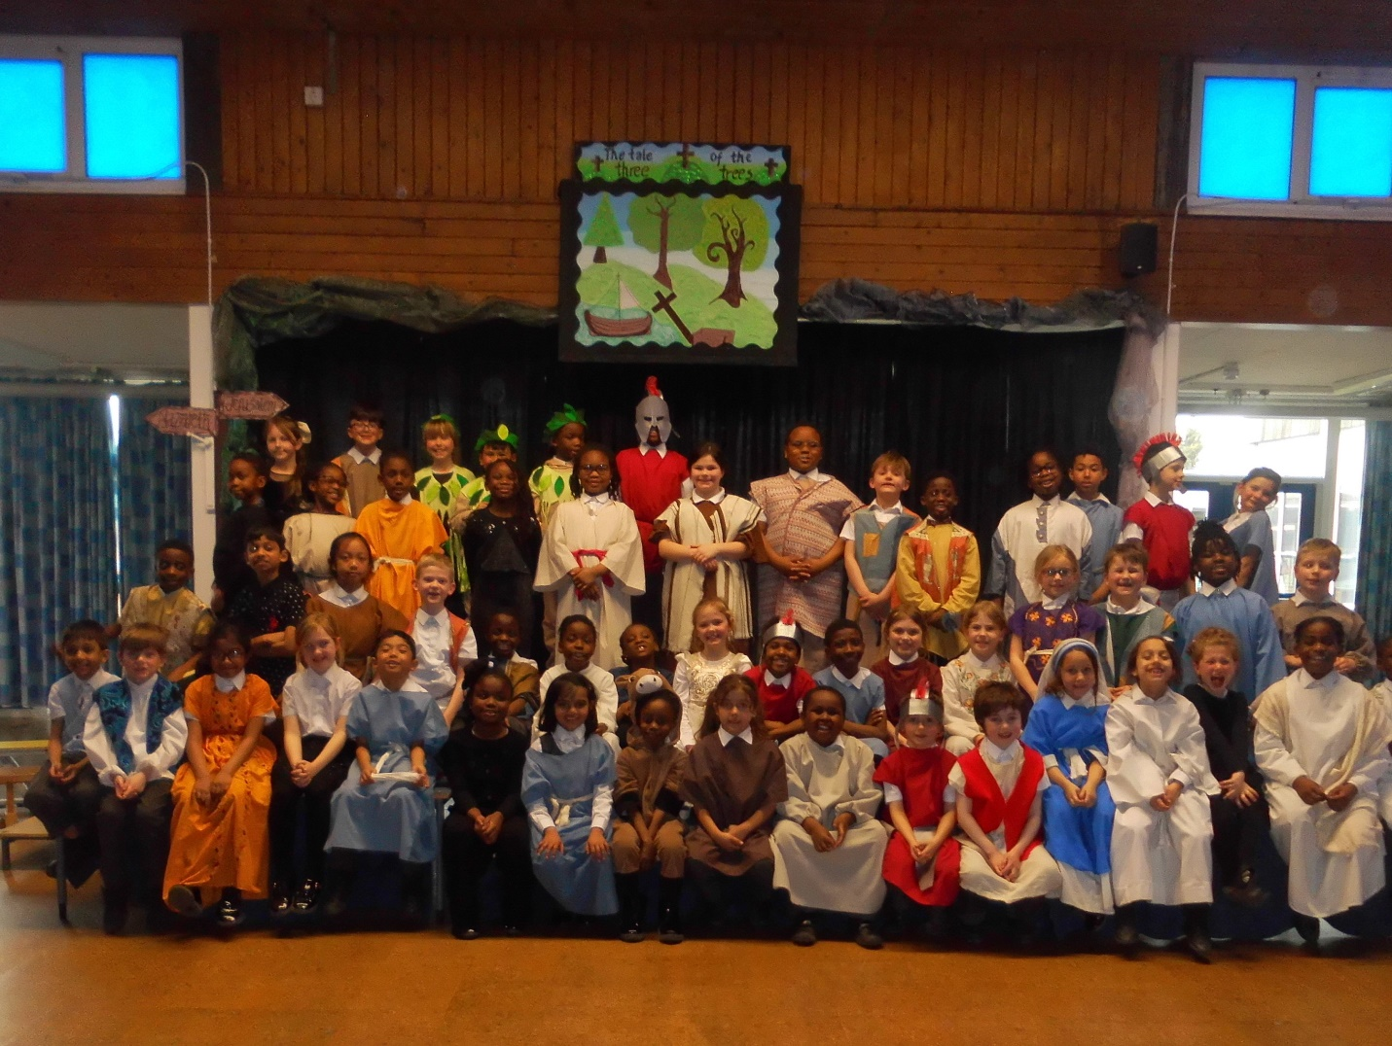
Well done to our Year 3 for their Easter Reflection.
They told us the story of ‘The Three Trees’ reminding us, not just of the Easter messages, but that just like Jesus, we have all been created by God for great things.

