CAFOD Club

Our school CAFOD club is an after school club currently open to Year 4 and 5 children. In CAFOD club, children explore ways they can brighten up the world, make the world a better place and reach people who urgently need our help. They reflect on Catholic Social Teaching and how God wants us to look after this world.

Our focus this half-term has been on Fair Trade and awe and wonder- appreciating the beauty of the natural world God created for us to live in.
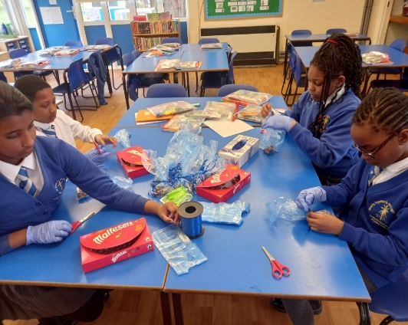

CAFOD Club- Fair trade Fortnig ht Stall Preparation

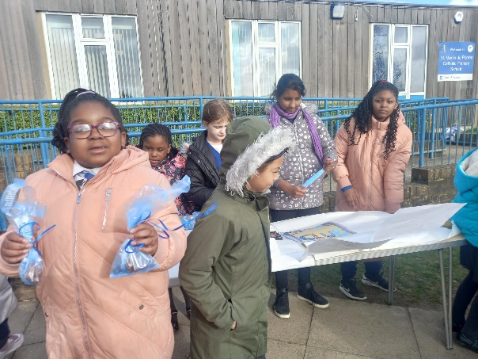

CAFOD Fairtrade stall

